**Hotel Room Reservation using JAVA.**

**INTRODUCTION AND PROJECT DESCRIPTION**

Hotel Booking application is a desktop based application used to book a reservation, update a reservation to view the reservation and delete the reservation. This application is built in java for the backend and java awt swing for the user interface. With the help of this application, we can book an reservation by providing details like name, number, email and type of the service needed.

**RUNNING INSTRUCTIONS AND SCREENSHOTS**

Using Eclipse to create a new java project as shown below.

Click finish to proceed.

Create a Database using mySQL

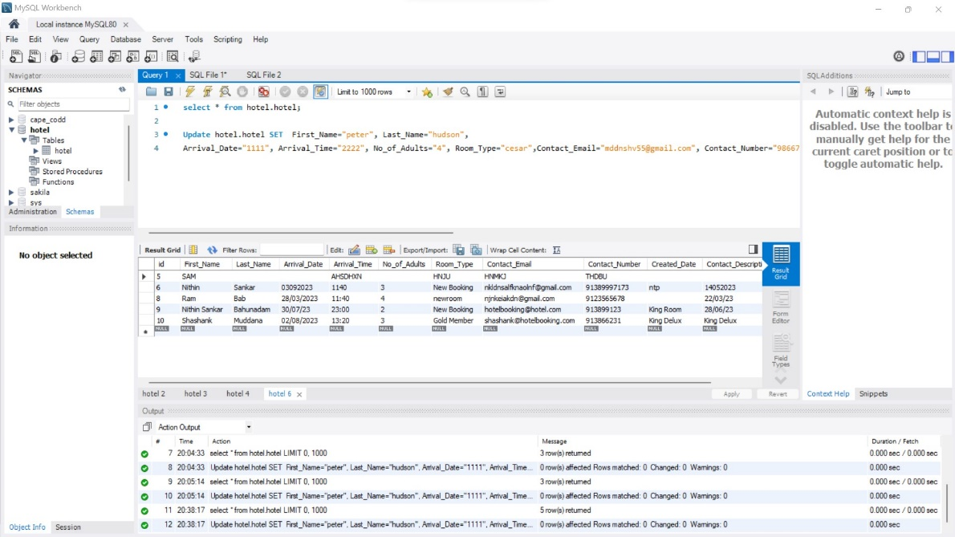

Click the Run as Java program button in hotelUI.java, which is where our main class is located, to launch the program.

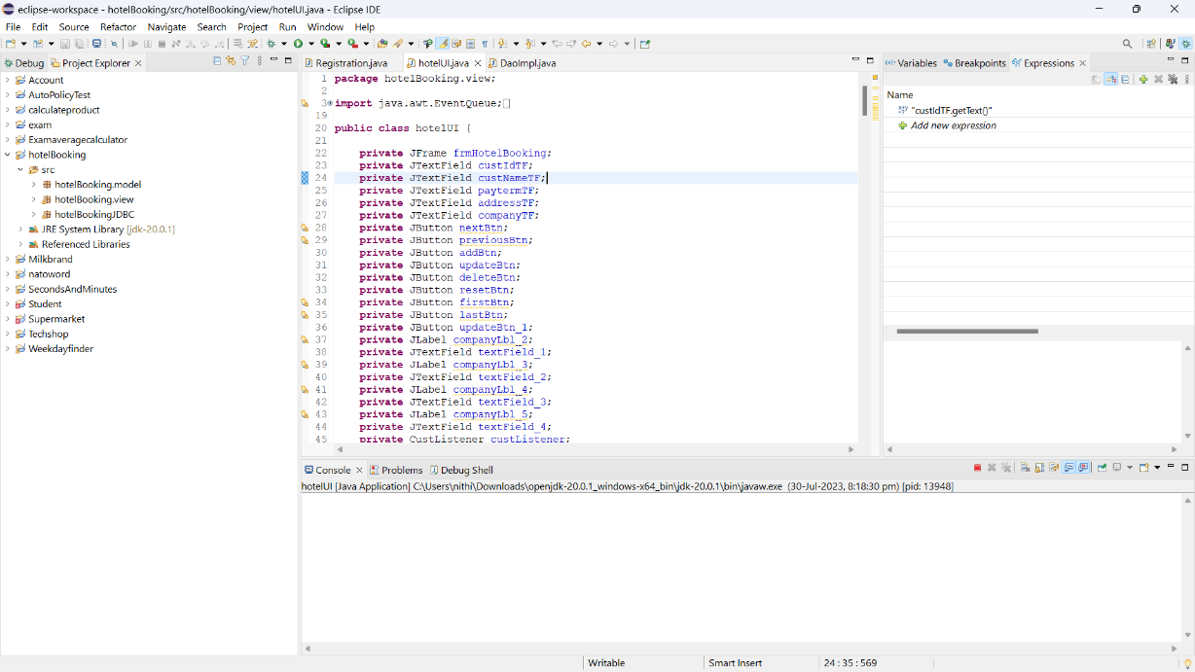

Open the application as shown in figure.

We have added four services and Reset in the application:

1. Add
2. Update
3. Get
4. Delete
5. Reset
6. In order to reserve a room at a hotel, we must enter information and click on ADD.

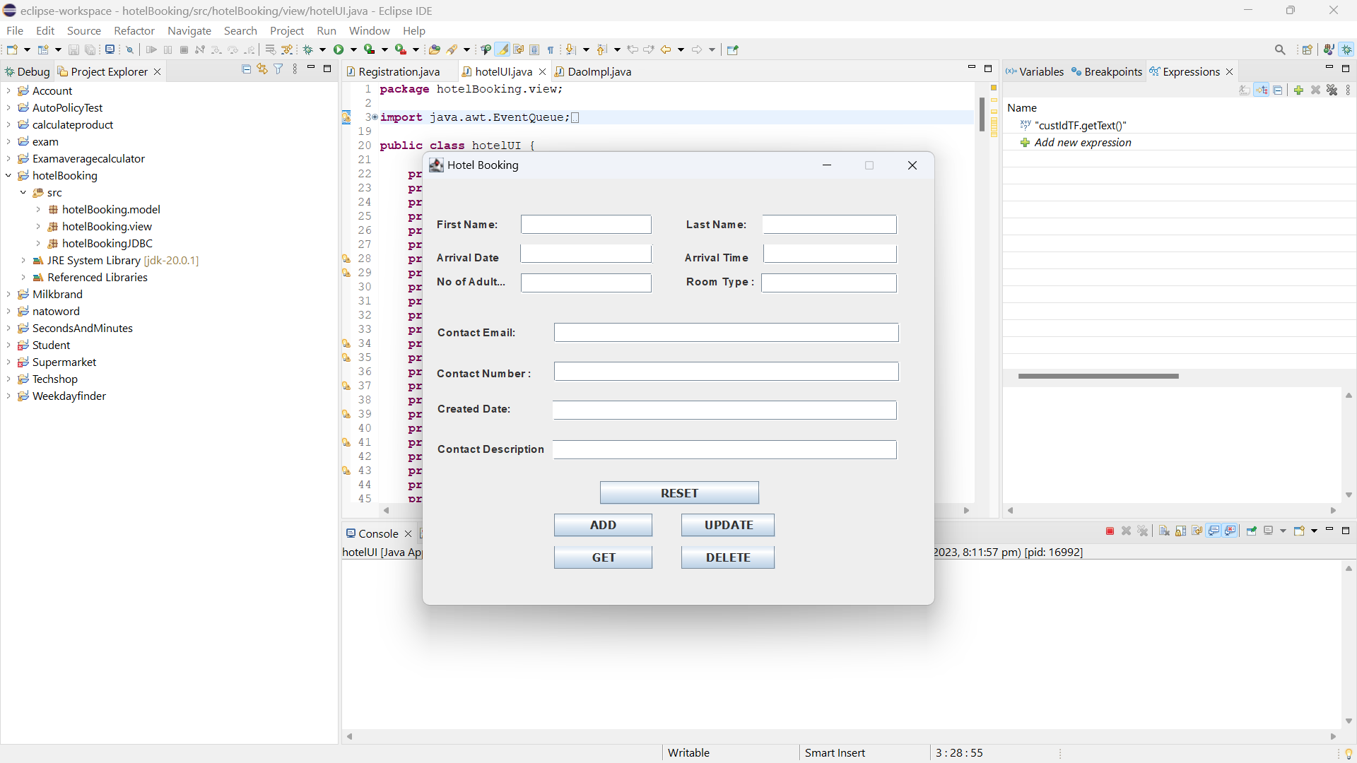

Insert the data required

After clicking on the Add button, the Reservation Successful will be shown as Reservation Booked.

1. To update the Reservation, we need to change the fields and click the UPDATE button. In the below image, we can see the update success as we changed the date of reservation from 30/07/2023 to 02/08/2023.

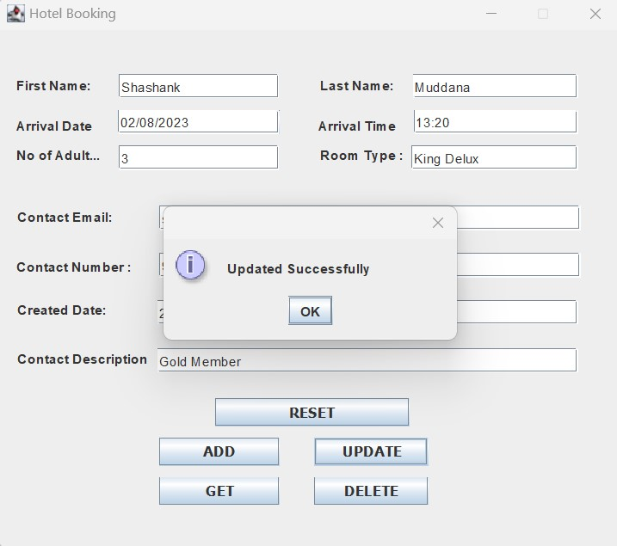

1. To view the Reservation, click on the GET button. This will ask us to enter the First Name. After providing the First Name we can see the appointment details.

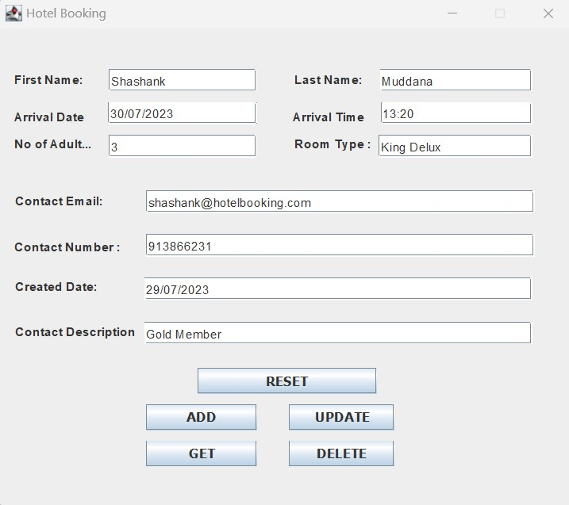

1. Click the DELETE button to remove the reservation.

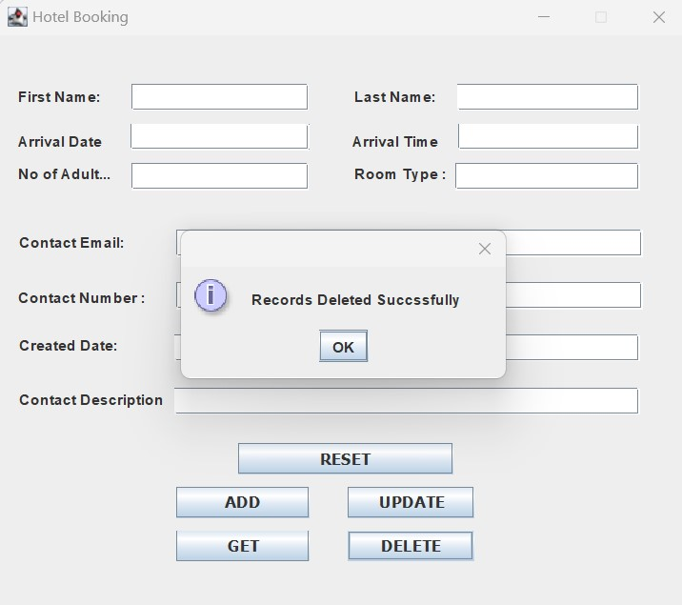

1. To clear the form, click on Reset Button. This will remove all the data in the form.

**CODE STRUCTURE AND FEATURES**

The project contains three packages.

1. **hotelbooking.model** : In this package, we instantiate a model class Registration.java where we give the properties like for our project it will be

FirstName

LastName

ArrivalDate

ArrivalTime

NoOfAdults

RoomType

ContactEmail

ContactNumber

CreatedDate

ContactDescription

1. **hotelBooking.view:** In this package, we create a user interface hotelUI.java by right clicking on the package to create a new wizard. Select the window Builder. Click on the Application Window. Click on next and give the name and click Ok.

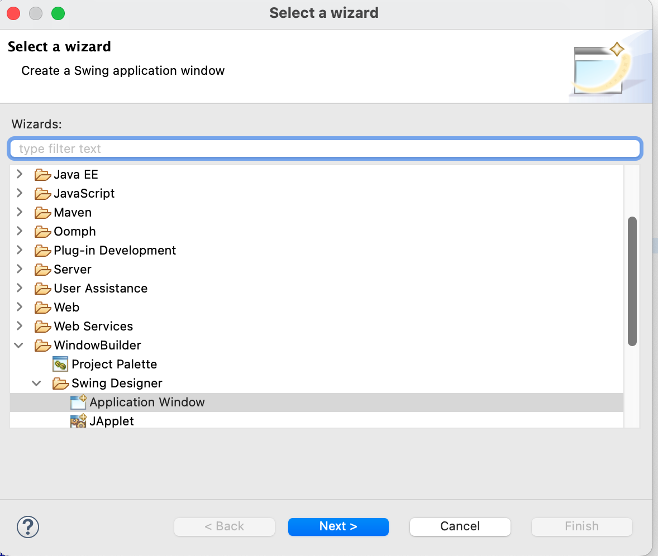

1. **hotelBookingJDBC:** In this package, we implement the database layer DaoImpl.java by adding database properties and do the CRUD operations.

We will use the MySql driver in the project to connect to the database.

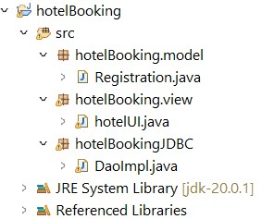

**Steps to develop the code**

**Prerequisites :**

To create Java Swing apps, install the WebBuilder program from the eclipse Marketplace.

Download mysql connector jar file from the internet.

1. Create a basic java project by right clicking on file -> new project -> Java project -> Create.
2. After creating the project, we must make packages by right-clicking on the src file and selecting "Create a New Package." Create classes in each of the packages.
3. To load the mysql jar file, right click on the project -> click on build path -> configure build path -> In the libraries tab, on the classpath right click -> add external jar file. Here we need to provide our downloaded jar file.
4. Once the project is set up we need to create our properties class and generate getters and setters.
5. For the User Interface, we can design our application directly by using drag and drop features provided by awt swing.
6. Once the design is completed we need to add functionalities to the design.

To read the values from the input fields we can use the .getText() method. The values from the UI need to be binded to the properties class which we already created ( getters and setters ).

To create an action event for the buttons, we have to use event listeners and create methods for each functionalities.

1. These static methods will be used in the database implementation. To connect to the database server, we need to add properties of the database server like hostname, port, username and password.
2. In each of the services, we need to create sql queries like insert, update, get and delete and assign the values to the properties class by using getters and setters methods.
3. The result coming from the services will be sent back to the UI and response will be shown in the application.

**References**

http://cswire.blogspot.com/2017/11/make-simple-crud-java-ui-application.html